**1. Debit Cards**

**2. Prepaid Cards**

**(Presented By Alan Stuart K)**

**1. Debit Cards:**

**Introduction**:

Debit cards are a pivotal financial tool in the US banking sector, allowing consumers to access their bank accounts directly to make purchases, withdraw cash, and manage their finances efficiently. Unlike credit cards, debit cards withdraw funds directly from a user's checking account, which helps in avoiding debt accumulation.

**Some Analysis**:

1. **Market Penetration**: Analysis of debit card adoption rates across different demographics and regions within the US.
2. **Transaction Volume**: Study of transaction volumes and values over time to understand consumer spending behaviours.
3. **Fee Structures**: Evaluation of fee structures associated with debit card usage, including transaction fees, overdraft fees, and foreign transaction fees.
4. **Security Measures**: Assessment of security features and fraud prevention mechanisms implemented by banks to protect debit card users.
5. **Customer Satisfaction**: Surveys and feedback analysis to gauge customer satisfaction levels with debit card services.

**Use Cases**:

1. **Everyday Purchases**: Debit cards are widely used for daily transactions, such as groceries, dining, and fuel.
2. **Bill Payments**: Many consumers use debit cards to pay utility bills, rent, and other recurring expenses.
3. **Online Shopping**: The convenience of debit cards extends to e-commerce, allowing for secure online purchases.
4. **ATM Withdrawals**: Debit cards provide easy access to cash through ATMs, essential for those needing physical currency.
5. **Travel**: Debit cards are used for booking travel services and making purchases while traveling domestically and internationally.

**Applications**:

1. **Mobile Payments**: Integration with mobile payment platforms like Apple Pay, Google Wallet, and Samsung Pay for seamless, contactless transactions.
2. **Personal Budgeting Tools**: Many banks offer tools that track spending through debit card transactions, helping users manage their budgets effectively.
3. **Reward Programs**: Some debit cards come with rewards programs, offering cashback, discounts, or points for purchases.
4. **Fraud Detection Systems**: Advanced algorithms analyse transaction patterns to detect and prevent fraudulent activities.
5. **Digital Banking**: Enhanced digital banking experiences where debit cards are linked to mobile banking apps for real-time transaction monitoring and management.

**Data**: Debit Cards in US Banking Sector:

| **Metric** | **Value** |
| --- | --- |
| **Number of active cards** | **~315 million** |
| **Annual transaction volume** | **$3.7 trillion** |
| **Average transaction amount** | **$42** |
| **Market penetration** | **82%** |
| **Annual growth rate** | **4.5%** |
| **Fraud rate** | **0.07%** |
| **Average cards per household** | **2.6** |
| **Contactless adoption rate** | **75%** |

**2. Prepaid Cards:**

**Introduction**:

Prepaid cards are a versatile financial instrument within the US banking sector, allowing consumers to load funds onto a card that can be used for various transactions. Unlike debit and credit cards, prepaid cards are not linked to a bank account or line of credit, offering greater control over spending and budgeting.

**Some Analysis**:

1. **Market Trends**: Examination of growth trends in prepaid card usage, including consumer preferences and market demand.
2. **Usage Patterns**: Analysis of transaction data to understand how and where prepaid cards are being used most frequently.
3. **Fee Analysis**: Breakdown of fees associated with prepaid cards, such as loading fees, monthly maintenance fees, and ATM withdrawal fees.
4. **Demographic Insights**: Study of demographic factors influencing the adoption of prepaid cards, including age, income levels, and geographic location.
5. **Regulatory Impact**: Review of regulations affecting the prepaid card industry, including consumer protection laws and financial compliance requirements.

**Use Cases**:

1. **Gift Cards**: Prepaid cards are popular as gift cards, providing recipients with the flexibility to choose their purchases.
2. **Travel**: Used as travel cards to manage travel expenses and avoid carrying large amounts of cash.
3. **Teen Spending**: Parents use prepaid cards to give their teenagers a controlled access to funds, teaching them financial responsibility.
4. **Unbanked Population**: Prepaid cards serve the unbanked or underbanked population, offering a secure way to manage money without a traditional bank account.
5. **Corporate Incentives**: Companies use prepaid cards for employee rewards, bonuses, and travel allowances.

**Applications**:

1. **Payroll Solutions**: Employers use prepaid cards to pay wages to employees, particularly those without traditional bank accounts.
2. **Government Benefits**: Distribution of government aid and benefits, such as unemployment benefits and social security payments, through prepaid cards.
3. **Expense Management**: Prepaid cards are used for managing and tracking expenses in businesses, especially for travel and entertainment.
4. **Educational Institutions**: Schools and colleges use prepaid cards for student stipends, grants, and meal plans.
5. **Online Shopping**: Prepaid cards offer a secure method for online shopping, limiting exposure to the user’s primary bank accounts.

**Data**: Prepaid Cards in US Banking Sector:

| **Metric** | **Value** |
| --- | --- |
| **Number of active cards** | **~140 million** |
| **Annual transaction volume** | **$450 billion** |
| **Average transaction amount** | **$37** |
| **Market penetration** | **28%** |
| **Annual growth rate** | **7%** |
| **Reload frequency** | **3 times/month** |
| **Average balance** | **$165** |
| **Government benefit cards** | **22% of market** |

**Graphs**:

**Graph 1:** Stock Prices for Visa and Mastercard (Last 5 Years):

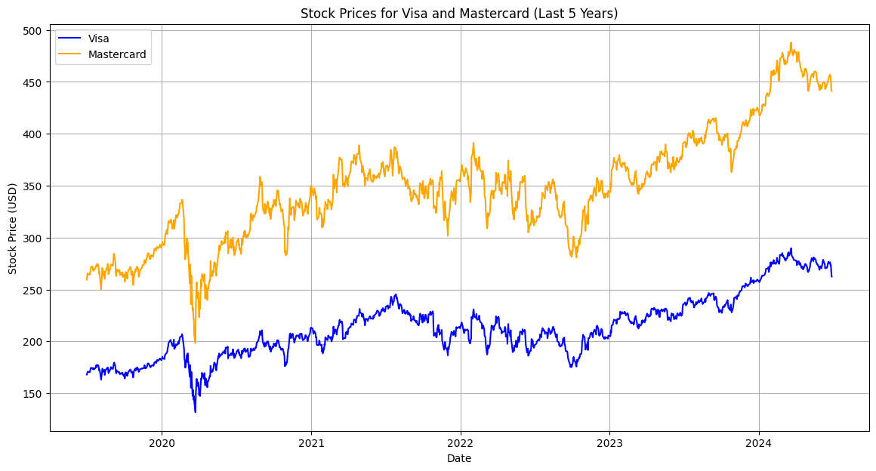**Inference:**

* Both Visa and Mastercard have shown significant growth in their stock prices over the last five years.
* Visa’s stock price has experienced a steady upward trend with occasional dips, reflecting overall investor confidence.
* Mastercard’s stock price follows a similar upward trend, indicating that the market perceives both companies as strong performers.
* The parallel movement in their stock prices suggests that factors influencing one company also tend to affect the other.
* This consistency in stock price movement highlights the stability and dominance of Visa and Mastercard in the financial services sector, particularly in the card payments market.

**Graph 2:** Volume of Stocks Traded for Visa and Mastercard (Last 5 Years):

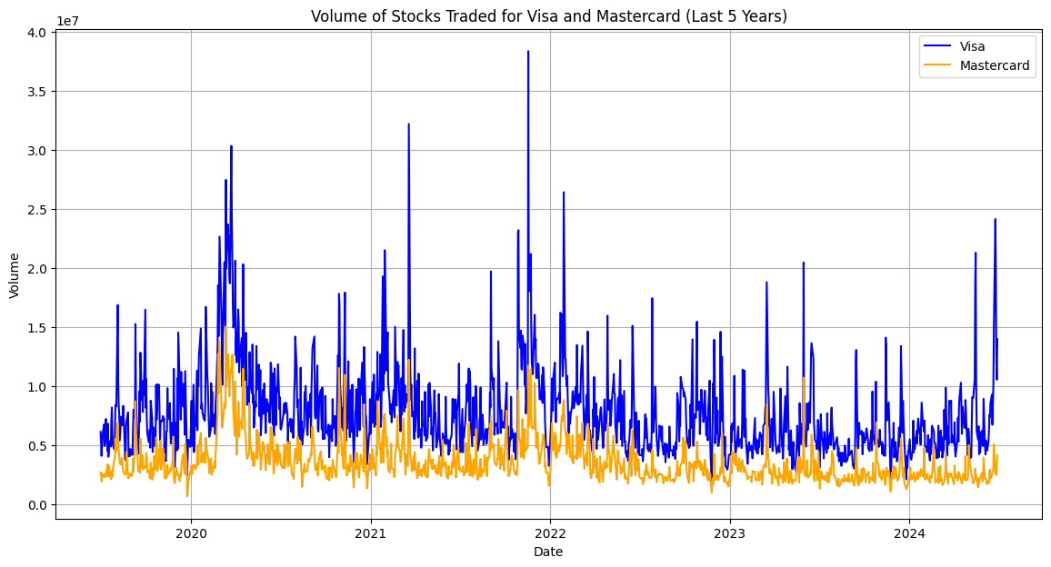**Inference:**

* The volume of stocks traded for both Visa and Mastercard shows significant spikes at certain points, which may correspond to major company announcements, earnings reports, or broader market events.
* Visa's trading volume generally appears higher than Mastercard's, suggesting higher liquidity and possibly greater investor interest.
* Periodic surges in trading volume could indicate heightened investor activity in response to market news or changes in the financial landscape.
* Consistently high trading volumes reflect strong investor engagement and confidence in these stocks.
* Understanding these volume patterns can help investors make more informed decisions about entry and exit points.

**Graph 3:** 50-Day Moving Average of Stock Prices for Visa and Mastercard (Last 5 Years):

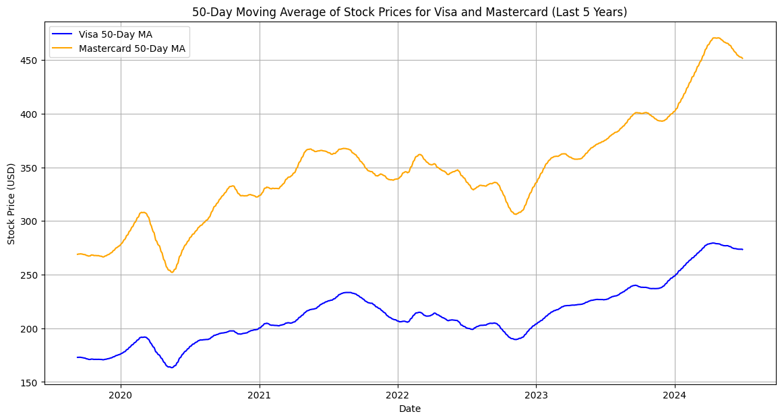**Inference:**

* The 50-day moving average smoothens short-term fluctuations and highlights the longer-term trends for Visa and Mastercard.
* Both companies show a strong upward trend in their 50-day moving averages, reinforcing the positive long-term performance observed in their stock prices.
* The occasional dips below the moving average could indicate temporary corrections or market pullbacks.
* A sustained movement above the 50-day moving average typically signals a bullish market sentiment.
* Investors often use the moving average as a key indicator to assess the overall trend and potential future performance of a stock.

**Graph 4:** Correlation Heatmap between Visa and Mastercard Stock Prices and Volume:

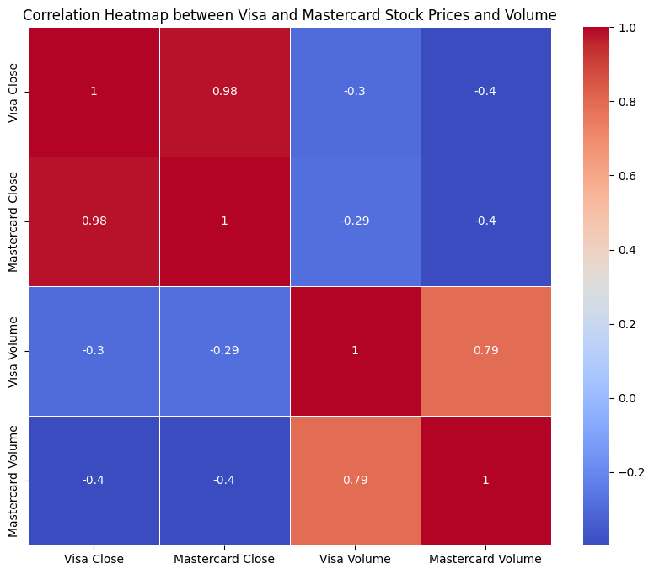**Inference:**

* The heatmap shows a strong positive correlation between the stock prices of Visa and Mastercard, indicating that their prices move in tandem.
* There is a weaker correlation between the stock prices and trading volumes of each company, suggesting that price movements are not solely driven by volume changes.
* The high correlation between Visa's and Mastercard's stock prices underscores their similar market behaviour and the interrelated nature of their business models.
* Understanding these correlations helps in risk management and diversification strategies for investors.
* The heatmap provides a quick visual representation of the relationships between different variables, aiding in more efficient analysis.

**Graph 5:** Candlestick Chart for Visa (Last 5 Years):

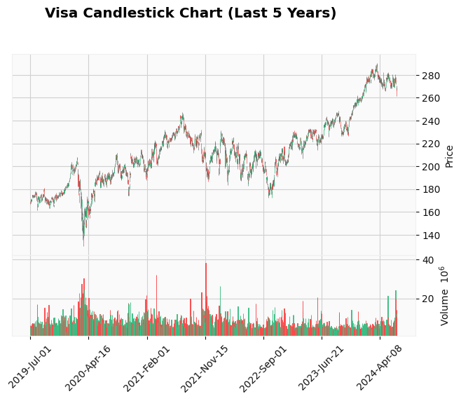**Inference:**

* The candlestick chart provides a detailed view of Visa's stock price movements, showing the open, high, low, and close prices for each trading period.
* Significant upward or downward movements can be easily identified, along with the length and position of wicks indicating price volatility.
* Patterns such as Doji, Hammer, or Engulfing can be spotted, offering insights into potential trend reversals or continuations.
* Candlestick charts are valuable for technical analysis, helping traders to make informed decisions based on historical price patterns.
* This chart highlights periods of high volatility and stability, guiding investors on potential buying or selling opportunities.

**Graph 6:** Bollinger Bands for Visa (Last 5 Years):

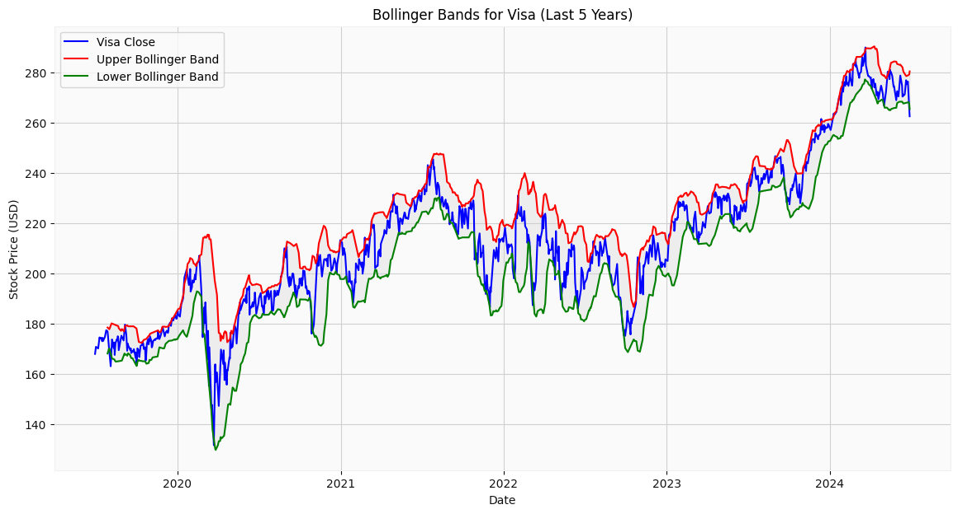**Inference:**

* Bollinger Bands provide a visual representation of Visa's stock price volatility by showing the upper and lower bands around a 20-day moving average.
* Periods when the stock price moves close to the upper band suggest overbought conditions, while movements near the lower band indicate oversold conditions.
* The width of the bands expands and contracts with changes in volatility, offering insights into market sentiment.
* Consistent movements within the bands suggest stability, while frequent breaches indicate higher volatility.
* Bollinger Bands are useful for identifying potential breakout points and assessing market conditions for strategic trading decisions.

**Graph 7:** Distribution of Daily Returns for Visa and Mastercard (Last 5 Years):

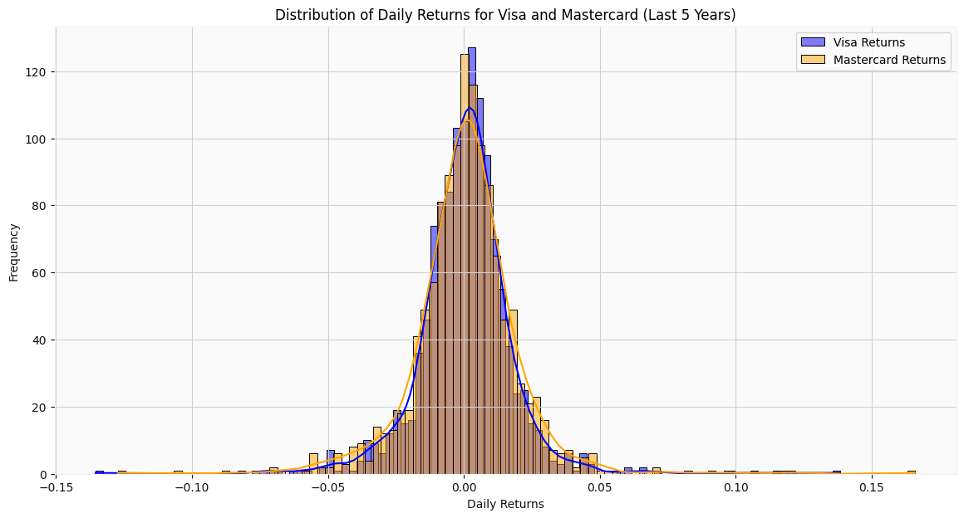**Inference:**

* The distribution of daily returns for Visa and Mastercard shows the frequency of different return levels over the last five years.
* Both distributions are centred around a mean close to zero, with a slight positive skew, indicating more frequent small positive returns.
* The presence of fat tails in the distributions suggests occasional large positive or negative returns, highlighting potential risk.
* The higher peak for Visa indicates a higher frequency of returns near the mean, suggesting relatively stable performance.
* Understanding the distribution of returns helps investors gauge the risk and volatility associated with each stock.

**Graph 8:** Cumulative Returns for Visa and Mastercard (Last 5 Years):

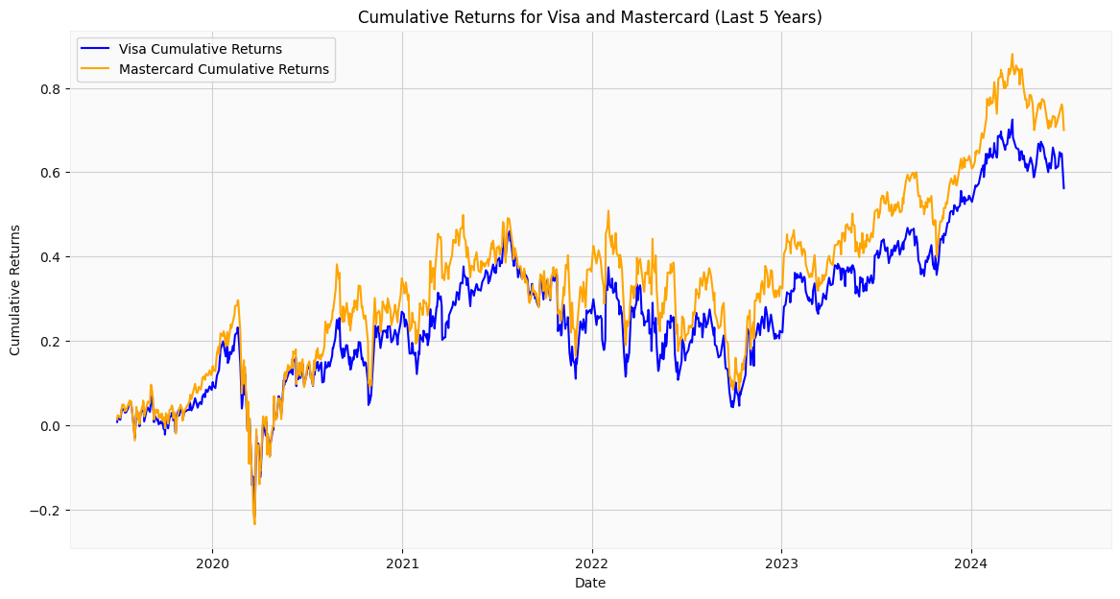**Inference:**

* The cumulative returns chart shows the compounded returns of Visa and Mastercard over the last five years.
* Both companies exhibit strong cumulative returns, with Mastercard slightly outperforming Visa over the entire period.
* The upward trend in cumulative returns reflects consistent positive performance and growth for both companies.
* Investors can use cumulative returns to assess long-term investment performance and compare it against benchmarks or other stocks.
* This chart provides a clear picture of the overall gains an investor would have achieved by holding these stocks over the specified period.

**Conclusion:**

Debit and prepaid cards are indispensable tools in the US banking sector, each serving unique purposes and catering to diverse consumer needs. Debit cards offer direct access to bank accounts, facilitating seamless everyday transactions, bill payments, and online shopping, while ensuring financial discipline by limiting spending to available funds. Prepaid cards, on the other hand, provide flexibility and control over expenditures without the need for a traditional bank account, making them ideal for gifts, travel, and serving the unbanked population. Both card types have evolved to include advanced features like mobile payment integration, fraud detection, and budgeting tools, enhancing user convenience and security. The analysis of market trends, transaction volumes, and usage patterns reveals a growing adoption of these financial instruments, driven by technological advancements and changing consumer preferences. By understanding the distinct benefits and applications of debit and prepaid cards, financial institutions can tailor their offerings to better serve their customers, promoting financial inclusion and stability. As the banking sector continues to innovate, these cards will play a crucial role in shaping the future of personal finance, providing accessible, secure, and efficient payment solutions for all.